**ANALYSING SPENDING BEHAVIOUR AND IDENTIFYING**

**INTRODUCTION:**

Consumer behaviour is the study of how individual customers, groups or organizations select, buy, use, and dispose ideas, goods and services to satisfy their needs and wants. It refers to the actions of the consumers in the market place and the underlying motives for those actions.

**EMPATHY MAP**

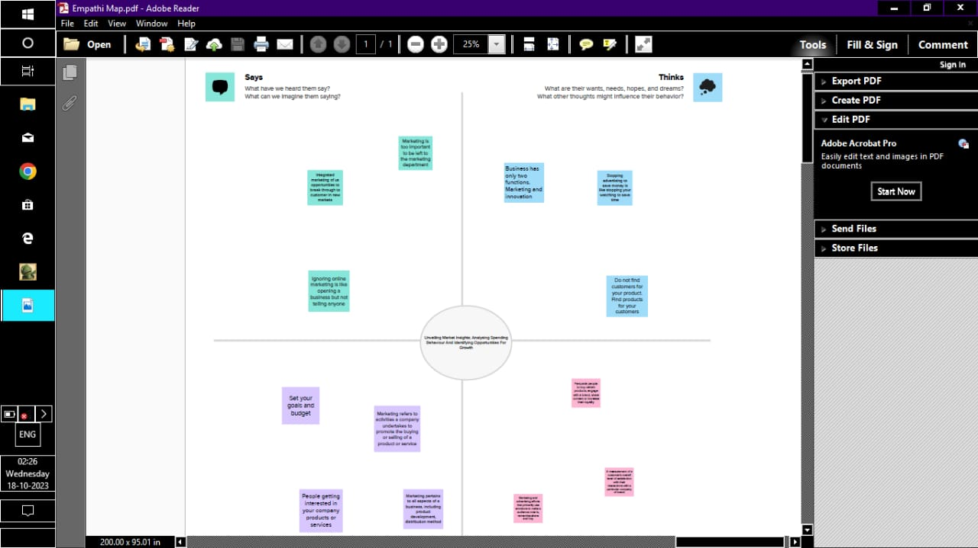

BRAINSTROMING

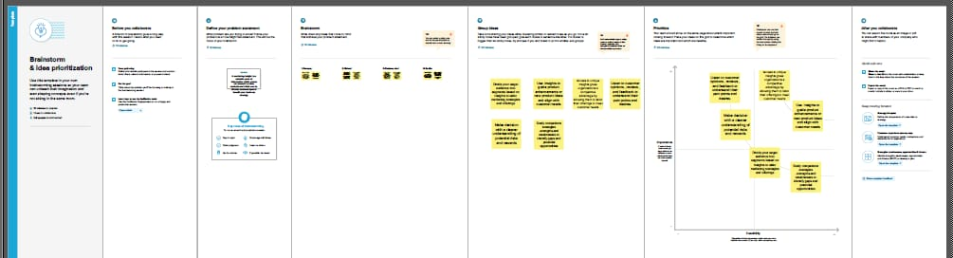

**RESULT**

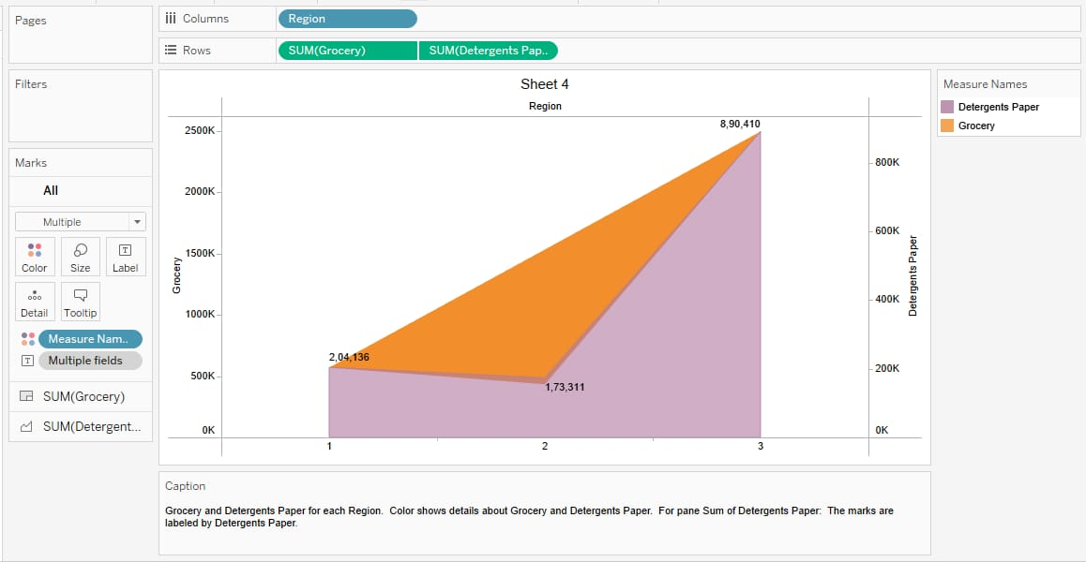

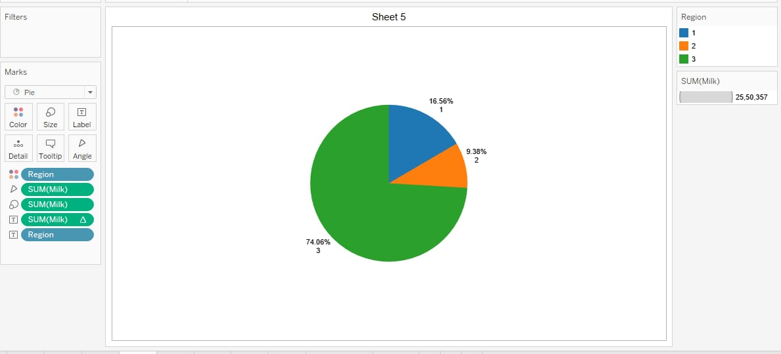

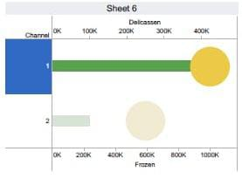

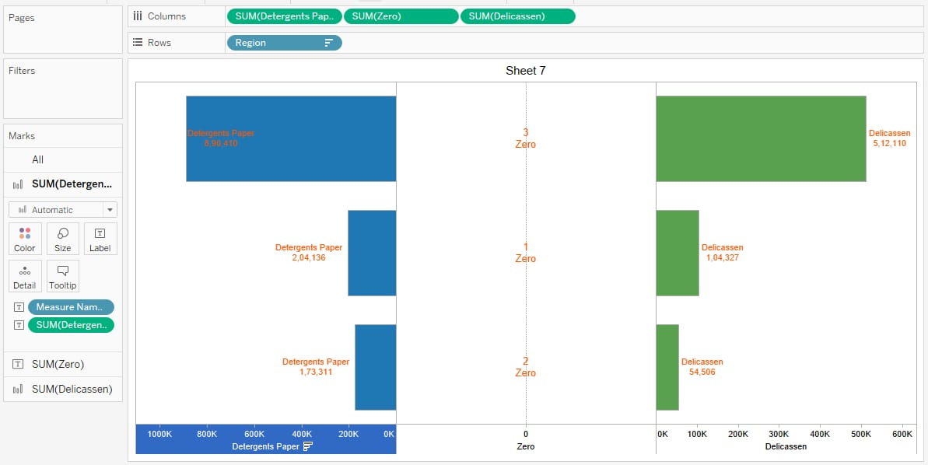

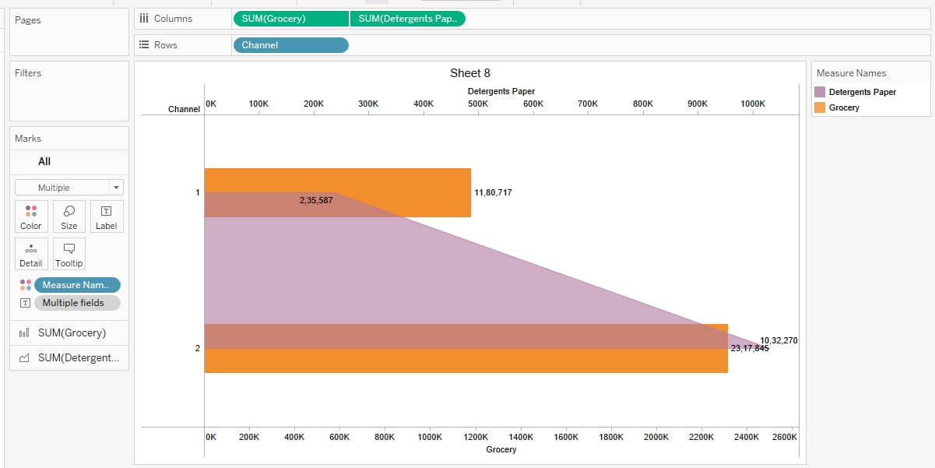

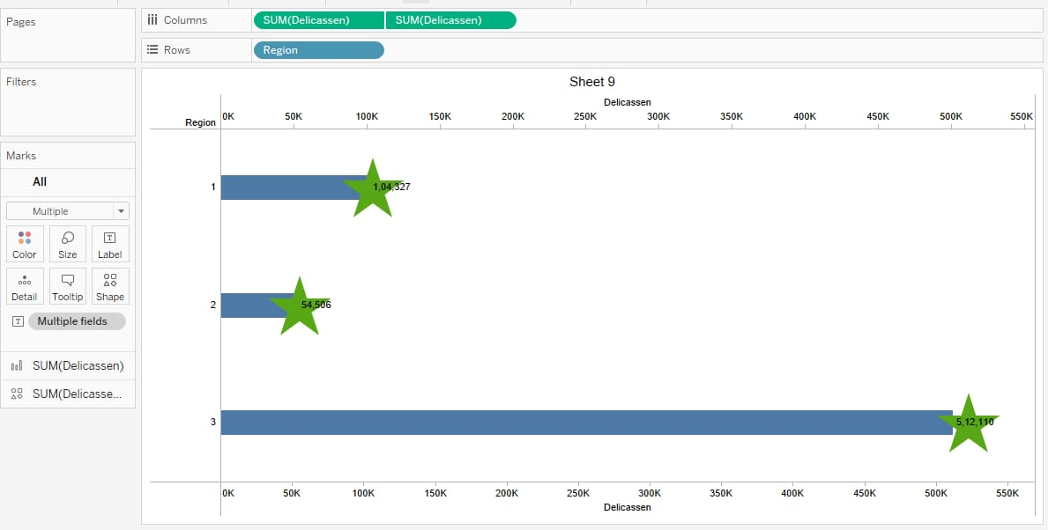

**ADVANTAGES:**

Consumers get the products and product features they want and don’t have to settle for a product that doesn’t meet all their needs.

**DISADVANTAGE:**

Consumers wants and needs change quickly and by the time a company offers a product the consumer wants, they will be on the next set of demand.

DASHBOARD

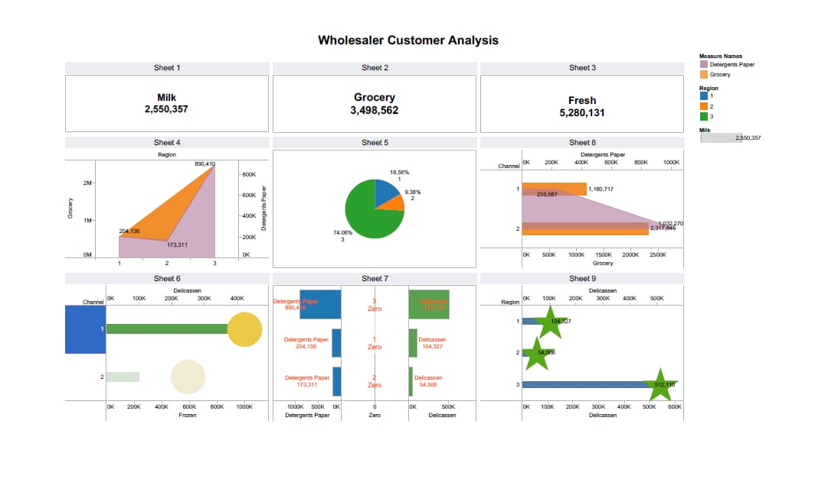

STORY









  


**CONCLUSION**:

Marketing research is crucial for ensuring that a company can understand the mindset of its customers. Based on the findings of these reports, they can develop products that can fulfil customer requirements. It’s strategic process that provides invaluable insights into a company’s spending habits.

**FUTURE SCOPE:**

The future of market research will be driven by technology, data analytics, and a focus on understanding customer needs and preferences. As the market continues to evolve, market research firms will need to stay on top of the latest trends and technologies in order to provide valuable insights to their clients.